The goal of this project was to create a bank application that allows multiple functionalities to bank employees and customers. Bank application or ATM machine projects usually allow implementations for customers or employees. Our goal was to create one that can be used by both.

The potential users for this project are bank employees who can implement numerous functionalities like: Add a new customer, Create and delete an account, Display customer details and Process monthly statements. This bank application is also intended for customers who can implement the following functionalities: Check balance, Deposit, Withdraw and Print monthly statement.

Following are a few functionalities of our application and their use cases:

**Use Case Diagram of Bank Account (checking account)**

As seen in the checking account use case diagram, customers can deposit, withdraw, check balance and transfer using their checking account. On the other hand, bank employees can delete account, create account and apply service fee for creating the account. It displays no balance error if there is no sufficient balance.

**Savings Account Use Case Diagram**

One user can have both Checking and Savings account, just checking account or just savings account. Bank customers using a savings account will be able to deposit balance to their account, withdraw money if there is suffient amount in the account. Customers will also be able to view their account balance and the monthly bank statements. Bank employees can create a new savings account or delete an existing account. They are also responsible for proceesing the monthly statement.

**Bank Service Case Diagram**

Bank Service displays all the available services. It allows to choose and view the options for Bank Employees, Bank customers or exit the application. While bank employees can add a new customer, Create and delete an account, Display customer details and Process monthly statements, bank customers can Check balance, Deposit, Withdraw and Print monthly statement.

**Check Balance Use Case**

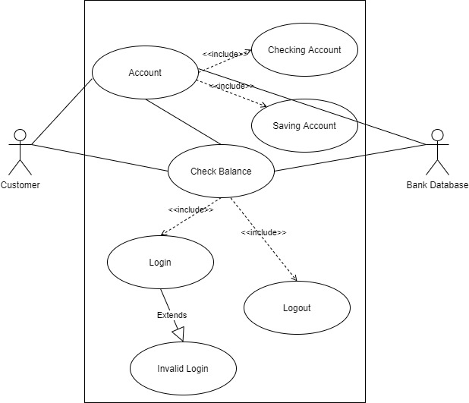

This use case will implement a check balance action of either the checking account or the saving account. The customer will choose the account of their preference to check their balance. It will include the login functionality to authenticate the user. In the case of wrong credentials, the invalid login message will appear. Once the user views the balance, they will be able to logout of their account. All the functionality interact with the bank database to obtain the necessary information.

**Software Use Case**

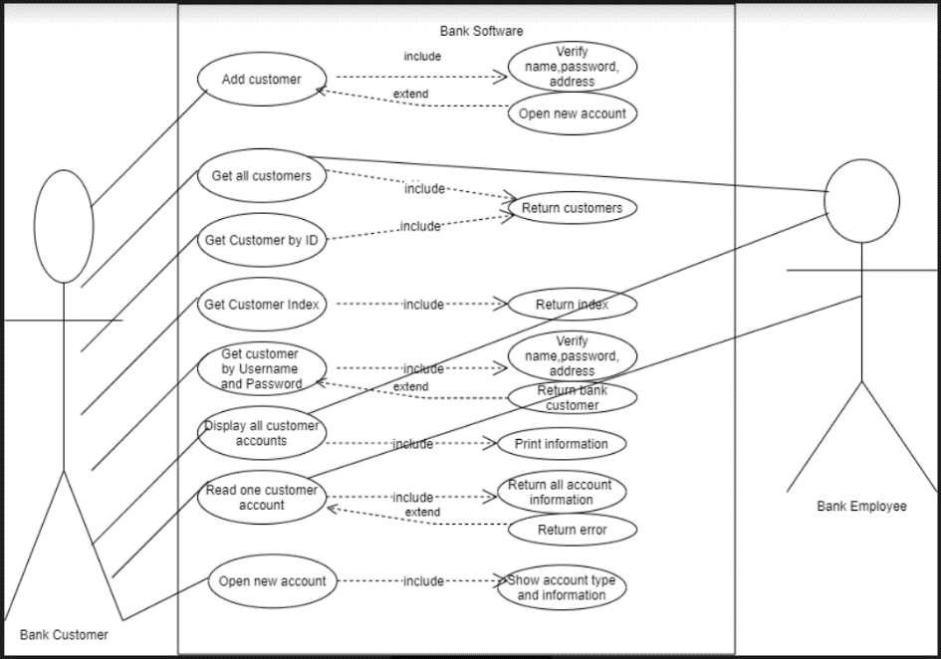

The application helps users to perform their bank service. It helps the customer with various tasks from creating a new account to displaying all their account information. Also, the bank manager can view information about customers as well as their actions.